**Evaluation Exercise 3**

Thank you for agreeing to take part in this evaluation for Sift.

For this evaluation exercise, you will be 5 users and the properties that they have recently liked. You will then be shown a property that has been recommended for the user, based on the fact that it has been classed as similar to those that they have already liked.

For each user, state how similar you think the recommendation is to their recently liked properties, and how satisfied you think the user would be with the recommendation, rating both between 1 and 5.

**Results**

|  |  |  |
| --- | --- | --- |
| **User** | **Recommendation Similarity (1-5)** | **Satisfaction with Recommendation (1-5)** |
| **1** | 5 | 5 |
| **2** | 3 | 3 |
| **3** | 3 | 4 |
| **4** | 5 | 5 |
| **5** | 4 | 4 |

**User 1**

Recently Liked Properties:

Recommended Property:

**User 2**

Recently Liked Properties:

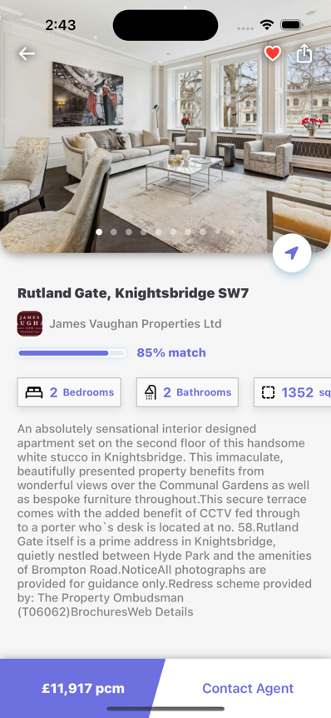 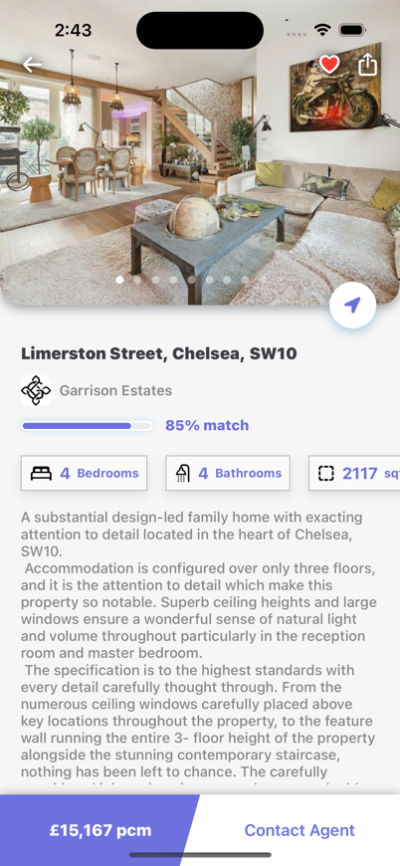

Recommended Property:

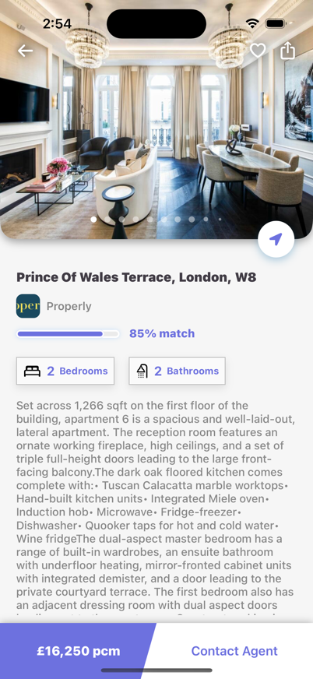

**User 3**

Recently Liked Properties:

Recommended Property:

**User 4**

Recently Liked Properties:

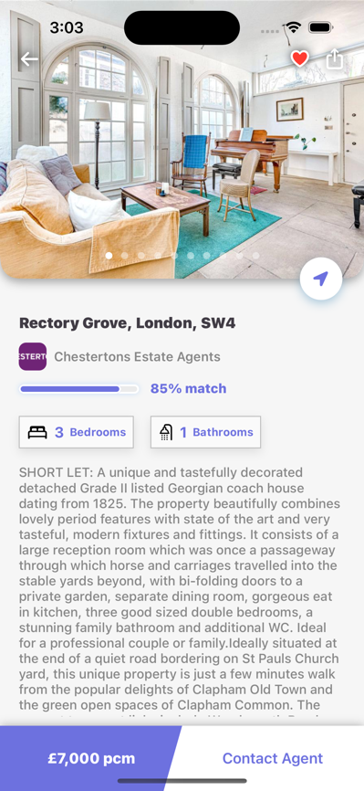

Recommended Property:

**User 5**

Recently Liked Properties:

Recommended Property:

